OUTPUT SCREENSHOT
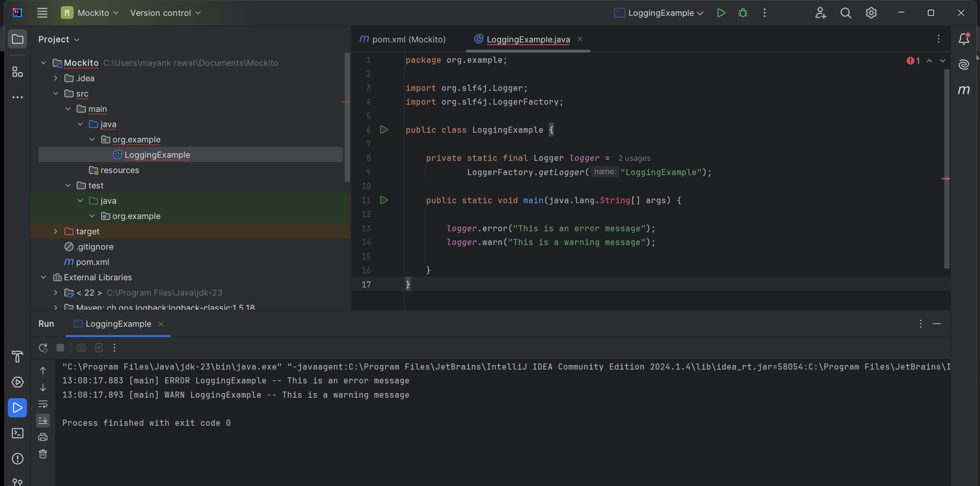

CODE:
LoggingExample
package org.example;

import org.slf4j.Logger;
import org.slf4j.LoggerFactory;

public class LoggingExample {

private static final Logger logger =
LoggerFactory.getLogger("LoggingExample");

public static void main(java.lang.String[] args) {

logger.error("This is an error message");
logger.warn("This is a warning message");

}
}

